AS3959

Obtaining a developed wind flow

* The distance between the inlet and the starting of forest = 120 m
* Set up velocity device at every 10 m interval.
* Inlet wind velocity: SEM method

|  |
| --- |
|  |
| |  | | --- | | 1.5 m 🞨 1.5 m 🞨1.5 m after 40 s of running. Previous CSV files used to initiate the flow. Inlet velocity is 20.71 m/s. | |

**At X=-48 m distance U10 =19.4540 m/s. Requirement is 19.44 m/s.**

\*\***Get 19.44 m/s at around x-50 m**

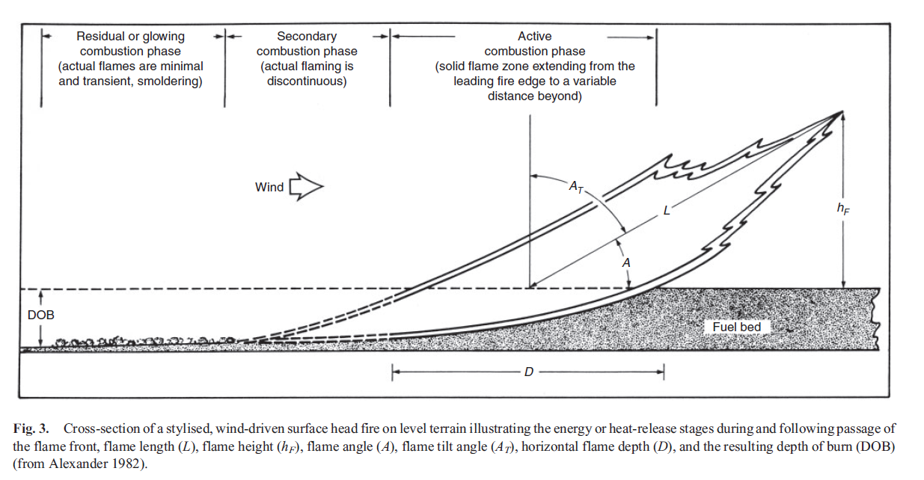Depth of the Fireline

According to Alexander et al [1], Flame depth:

**D= r.tr**

Where r is rate of spread and tr is residence time. As per Wotton et al [2], Average flame front residence time for eucalypt forest fuels was **37 s** and did not vary significantly with fine fuel moisture, fuel quantity or bulk density.

|  |  |  |  |  |
| --- | --- | --- | --- | --- |
| Vegetation classification | ROS | | tr | Flame depth  (m) |
| Km/h | m/s |
| **Forest** | **1.493** | **0.414** | **37** | **15.3** |
| **2.384** | **0.662** | **37** | **24.5** |
| **3.013** | **0.837** | **37** | **30.9** |
| Scrub | 4.555 | 1.265 | 45 | 56.9 |
| 7.441 | 2.066 | 45 | 92.9 |
| 8.966 | 2.491 | 45 | 112.1 |
| Mallee/Mulga | 4.555 | 1.265 | 45 | 56.9 |
| 7.441 | 2.066 | 45 | 92.9 |
| 8.966 | 2.491 | 45 | 112.1 |

**Scrub & Malle/Mulga residence time? 20 s? (pending)

**Find would be the flame depth for Filkov’s work?

Fire spread rate = 0.289 ±0.014 m/s (considering 5% uncertainty of estimation of arrival time from the video)

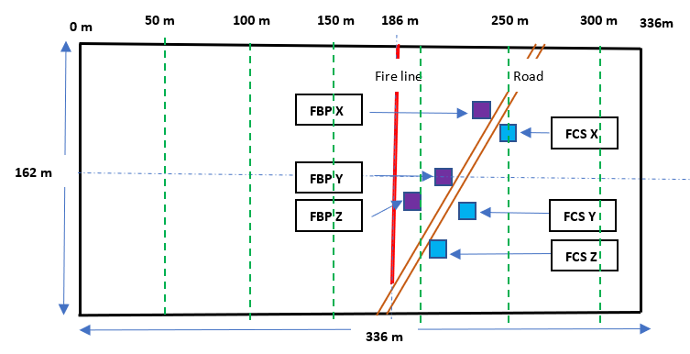

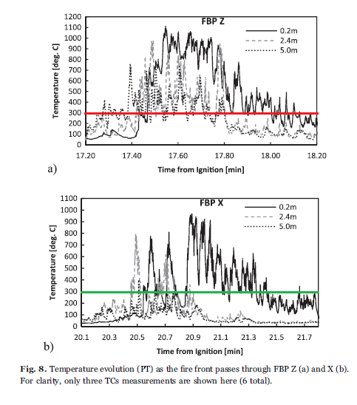

Tr profile at0.2 m height was considered to avoid the effect of radiation of the flame.

|  |  |  |  |
| --- | --- | --- | --- |
| Location | ROS (m/s) | Tr (seconds) | Fireline depth (m) |
| FBP Z | 0.289 | (18.12-17.43)🞨60 s = 41.4 | ≈12.0 |
| FBP X | 0.289 | (21.67-20.55)🞨60 s = 67.2 | ≈19.5 |

Firebrand inputting

42 types of firebrands including cylindrical, spherical, and cubic shapes and different sizes.

Initial velocity (U, V, W) = (8.3, 0.0, 2.1) m/s.

Firebrand input composition of prescribed fire.

Douglas fir tree burning

Examined **NU_MATL** and **NU_SPEC**

1. Grid 50 mm +Haider Drag model + (NU_MATL = **0.69**, NU_SPEC = **0.31**)

|  |
| --- |
|  |

Total mass loss difference between the experiment and the simulation = +8.5%.

1. Grid 50 mm +Haider Drag model + (NU_MATL = **0.61**, NU_SPEC = **0.39**)

|  |
| --- |
|  |

Total mass loss difference between the experiment and the simulation = -13%

AS3959 Firebrand generation source term calculation based on the **species, FMC,** and **wind velocity**

1. Species

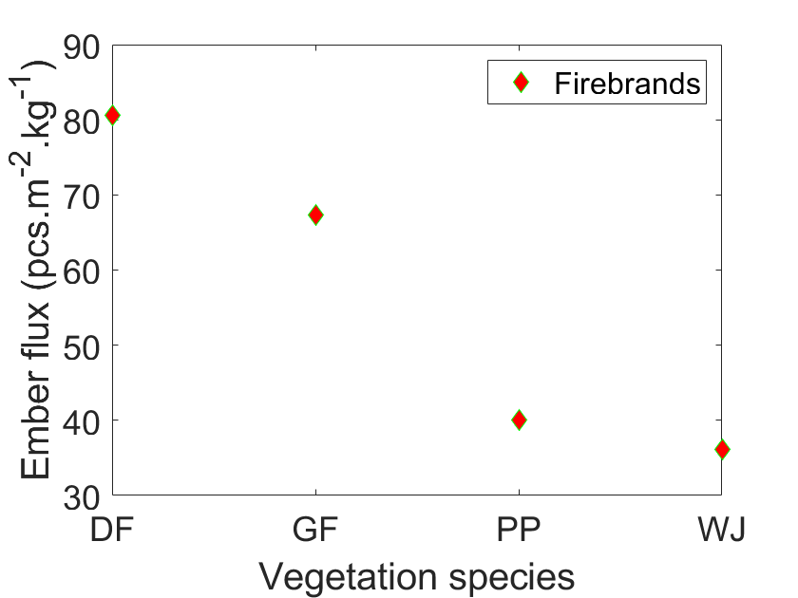

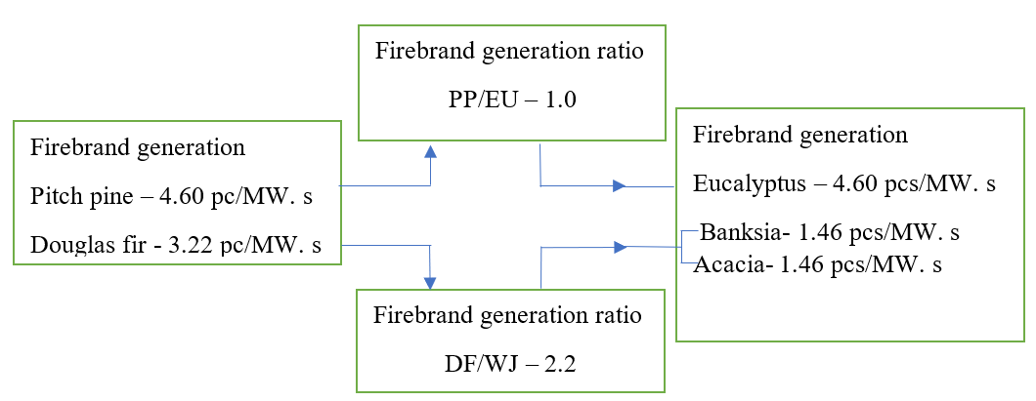

PP-pitch pine

DF-Douglas fir

WJ-Western Juniper

1. FMC

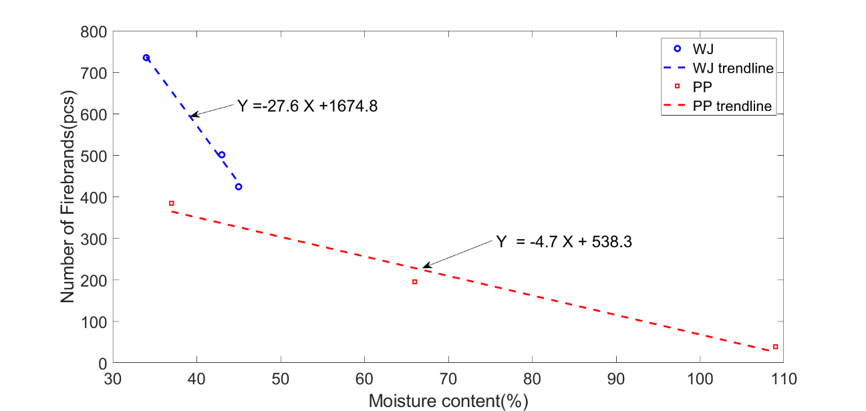

The number of firebrands generated varying the fuel moisture content (FMC) of Western Juniper (WJ) and Ponderosa Pine (PP). Increasing MC results decreasing in firebrand generation. The trend is linear, and it is given the equation of each trendline to find the number of firebrand generation at certain FMC.

|  |  |  |  |  |  |
| --- | --- | --- | --- | --- | --- |
| Vegetations | Firebrand generation rate  (pcs/MW.s) | MC (%) | Number of firebrands | Generation ratio to  3.22% MC | Generation rate (pcs/MW.s) |
| Western Juniper  Douglas fir  Banksia/Acacia | 3.22  (Douglas fir ) | 3.84 | 1569 | (1569/1398)=1.12 | 3.22🞨1.00=3.61 |
| 10 | 1398 | (1398/1398)=1.00 | 3.22🞨1.12=3.22 |
| Ponderosa pine  Pitch pine  Eucalyptus | 4.60  (Pitch pine) | 3.84 | 520 | (520/392)=1.33 | 4.60🞨1.00=6.10 |
| 31 | 392 | (392/392)=1.00 | 4.60🞨1.33=4.60 |

1. Wind effect

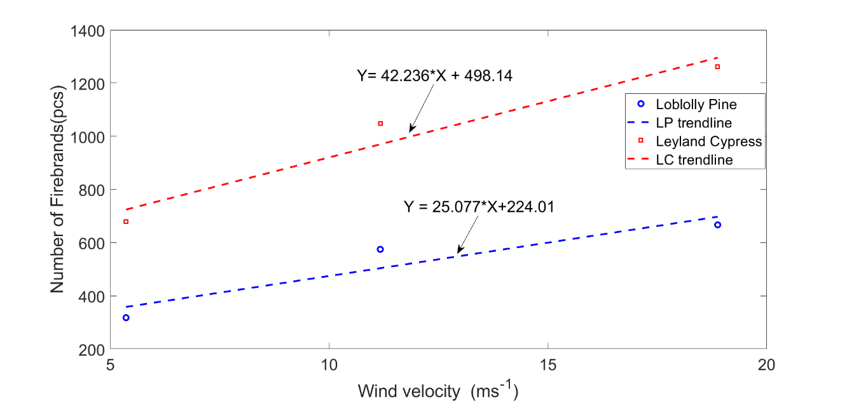

The experimental results of the number of firebrands collected in Idle, medium, and High wind speeds for Loblolly pine and Leyland cypress vegetations. Increasing wind speeds shows an increment of firebrands collection. The experiment was set up to collect all the firebrands generated in each tree burning of Bahrani et al.

|  |  |  |  |  |  |
| --- | --- | --- | --- | --- | --- |
| Vegetations | Firebrand generation rate  (pcs/MW.s) | Wind (m/s) | Number of firebrands | Generation ratio to  2 m/s and 0 m/s | Generation rate (pcs/MW.s) |
| Loblolly pine  Pitch pine  Eucalyptus | 4.60  (Pitch pine at  2 m/s) | 2 | 274 | (274/274)=1.00 | 4.60🞨1.00=4.60 |
| 11.11 | 503 | (503/274)=1.84 | 4.60🞨1.84=8.46 |
| 16.67 | 642 | (642/274)=2.34 | 4.60🞨2.34=10.76 |
| 19.44 | 712 | (712/274)=2.60 | 4.60🞨2.60=11.96 |
| Leyland Cypress  Douglas fir  Banksia/Acacia | 3.22  (Douglas fir  at 0 m/s) | 0 | 498 | (498/498)=1.00 | 3.22🞨1.00=3.22 |
| 11.11 | 967 | (967/498)=1.94 | 3.22🞨1.94=6.25 |
| 16.67 | 1202 | (1202/498)=2.41 | 3.22🞨2.41=7.77 |
| 19.44 | 1319 | (1319/498)=2.65 | 3.22🞨2.65=8.53 |

**Remove Dgl

Combined effect

|  |  |  |  |  |  |  |  |  |  |  |
| --- | --- | --- | --- | --- | --- | --- | --- | --- | --- | --- |
| Vegetation classification | Dominant fuel | Reference firebrand generation (pcs/MW/s) | Effect of (generation ratio) | | | | | Final firebrand generation (pcs/MW/s) | | |
| Species | Wind (m/s) | | | FMC |
| 11.11  (A) | 16.67  (B) | 19.44  (C) | (A) | (B) | (C) |
| Forest | Eucalyptus | 4.60 (Dgl) | 1.00 | 1.83 | 2.34 | 2.60 | 1.33 | 19.2 | 21.5 | 22.7 |
| Scrub | Banksia | 3.22 (PtP) | 0.45 | 1.94 | 2.41 | 2.65 | 1.12 | 11.3 | 12.8 | 13.6 |
| Mallee/Mulga | Acacia | 3.22 (PtP) | 0.45 | 1.94 | 2.41 | 2.65 | 1.12 | 11.3 | 12.8 | 13.6 |

1. Alexander, M.E. and M.G.J.I.J.o.W.F. Cruz, *Interdependencies between flame length and fireline intensity in predicting crown fire initiation and crown scorch height.* 2012. **21**(2): p. 95-113.

2. Wotton, B.M., et al., *Flame temperature and residence time of fires in dry eucalypt forest.* 2012. **21**(3): p. 270-281.